Database

Analyze whether to put all user information in the user table or to make another user account

How to ensure the uniqueness of the warehouse, not being accessed by multiple users at the same time？

user

user_id int(10)

root: tinyint(1) [Admin root : 0, renter : 2, lender: 1]

username varchar(150)

password varchar(128)

last_login datetime(6)

date_joined datetime(6)

first_name varchar(30)

last_name varchar(150)

email varchar(254)

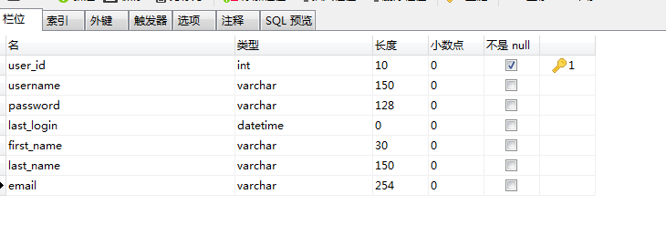

renter_account

user_id ->User(user_id) int(10)

balance float(200)

rented_warehouse

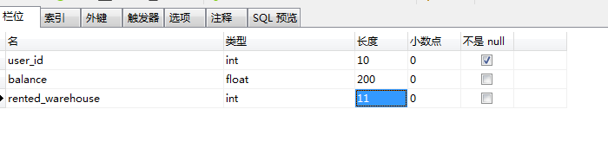

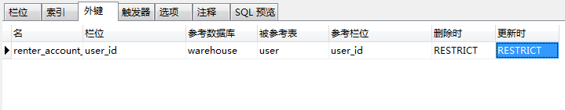

warehouse

warehouse_id int(11)

warehouse_name varchar(150)

warehouse_size int(10)

warehouse_desc varchar(254)

warehouse_image

warehouse_price

warehouse_category varchar(150)

warehouse_isAvailable tinyint(1)

warehouse_currentowenr_use_id int(10)

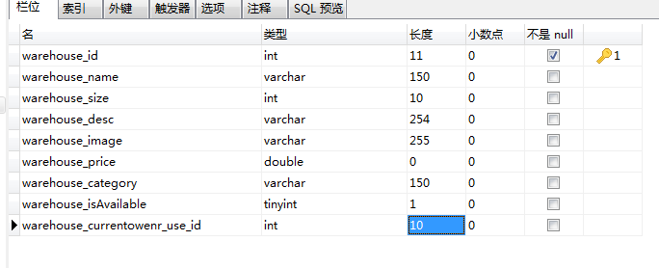

rent_order

order_id int(10)

user_id int(10)

order_date datetime(6)

